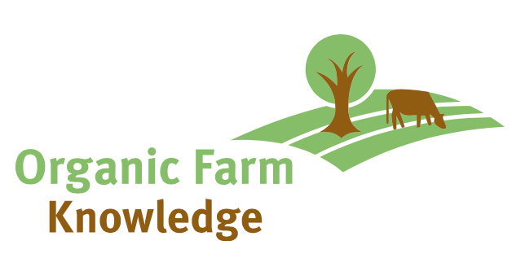
Organic Farm Knowledge Editorial Board
MEMBERSHIP AGREEMENT
Agreement between “Organisation” | and the
Name of the Organisation  Represented by  Legal representative  Contact person  Address  E-mail  Phone | Organic Farm Knowledge platform  Represented by  IFOAM Organics Europe  Dr. Bram Moeskops (R&I Manager)  c/o IFOAM Organics Europe  Rue du Commerce 124, 1000 Brussels  info@organicseurope.bio  Phone: +32 (0)2 416 27 61

Herewith, the above-mentioned organisation agrees to be officially member of the Editorial Board of Organic Farm Knowledge. The platform provides access to a wide range of tools and resources about organic farming that can help improve production. It also aims to serve as a virtual meeting place for cross-border learning, promoting the exchange of knowledge among farmers, farm advisers, and scientists, with the aim of increasing productivity and quality in organic farming across Europe.
The Editorial Board is responsible for the quality control of the tools and materials uploaded on Organic Farm Knowledge. It will keep the overview of the tools, identify tools for the platform, prepare tool descriptions, translate tool descriptions and web pages of Organic Farm Knowledge, revise tools of other platforms, keep the tools up-to-date and help promote Organic Farm Knowledge.
As a pre-condition to join the Editorial Board The organisation agrees to:
- In-kind contribution of at least 0.5 PM/year

The logo of the organisation will be visible on a dedicated page on Organic Farm Knowledge.

This agreement can be cancelled at any time by sending a letter to IFOAM Organics Europe. The resignation of membership becomes effective at the end of the calendar year in which the letter was received. Letters received after the 30th of November in any year will take effect from the end of the following calendar year.

For the organisation For IFOAM Organics Europe
Date and place: Date and place:
Stamp and Signature Stamp and Signature

Please email a scan of the signed agreement to bram.moeskops@organicseurope.bio.

